|  |
| --- |
| Circle Language Spec: Inheritance |

## Member Addition

The easiest technique for specialization by altering the member set is *member addition*. Here the concept of class inheritance is displayed:

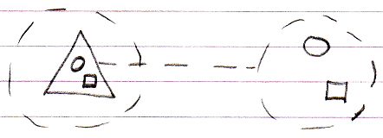

Member addition means adding a member, that was not there in the base, but will be in the derived object:

